**Deployment automation:**

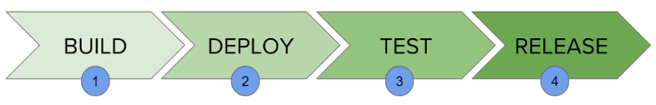

* This is the process and we use chain jobs for this

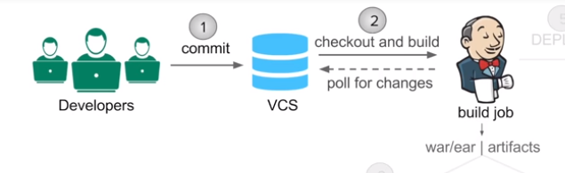

* This is the build stage

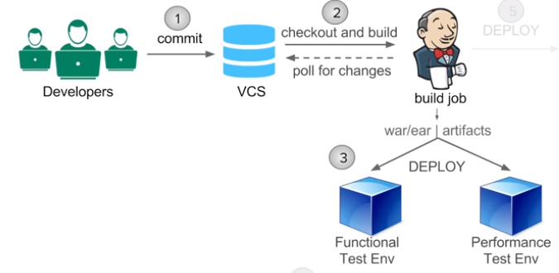

* This is deployment stage

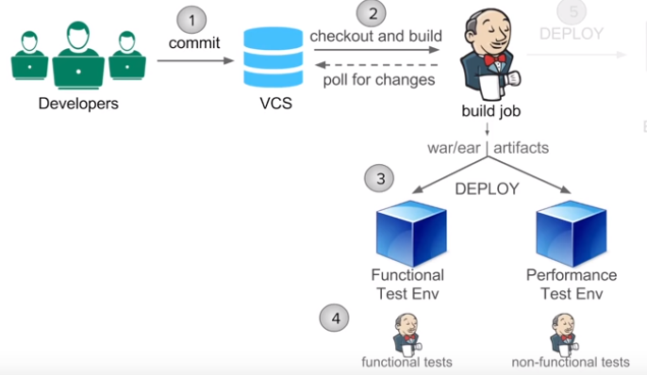

* Then the test jobs will be triggered

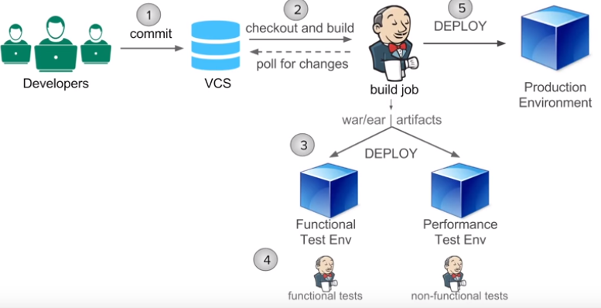

* Then we will deploy to production which is called release
* Deployment automation in Jenkins
* Download deploy to container plugin

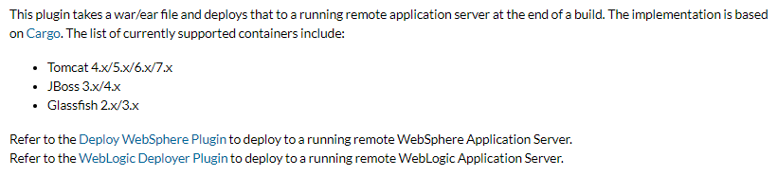

* Now, we get deploy war/ear to a container option under post build actions step

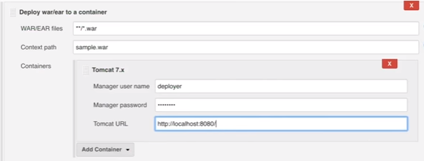

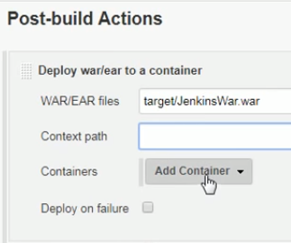

* War file gets stored in target folder. So, we need to give that
* Also, we need to give the below roles to tomcat admin user

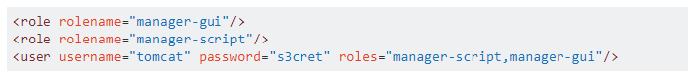

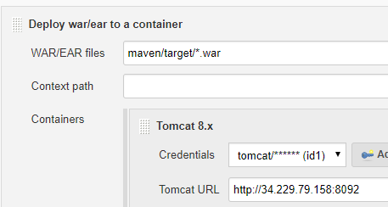

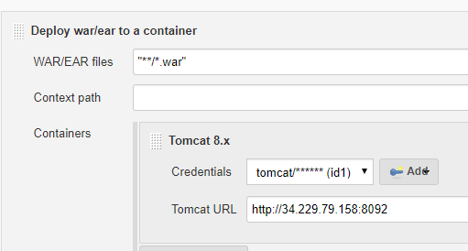

* **As above, *.war is not accepting by Jenkins. Post build task is not getting triggered when we give this**
* **But target/*.war is accepting as below**

